The Development Process

Student Workbook

Supports assessment for AS 91893 (4Cr)

Use this workbook together with
Project Log - Development Sprints

Student Guide 1
DEVELOPMENT 2
The Development Process 2
Outline 2
Use Advanced Techniques 2
Use Efficient Tools and Techniques 2
DEVELOPMENT SPRINT 3
Development Phase 1 - Plan 3
Aim 3
Plan 3
Development Phase 2 - Design 4
Aim 4
Design 4
Development Phase 3 - Develop 5
Develop 5
Development Phase 4 - Review 6
Test 6

DEVELOPMENT

The Development Process

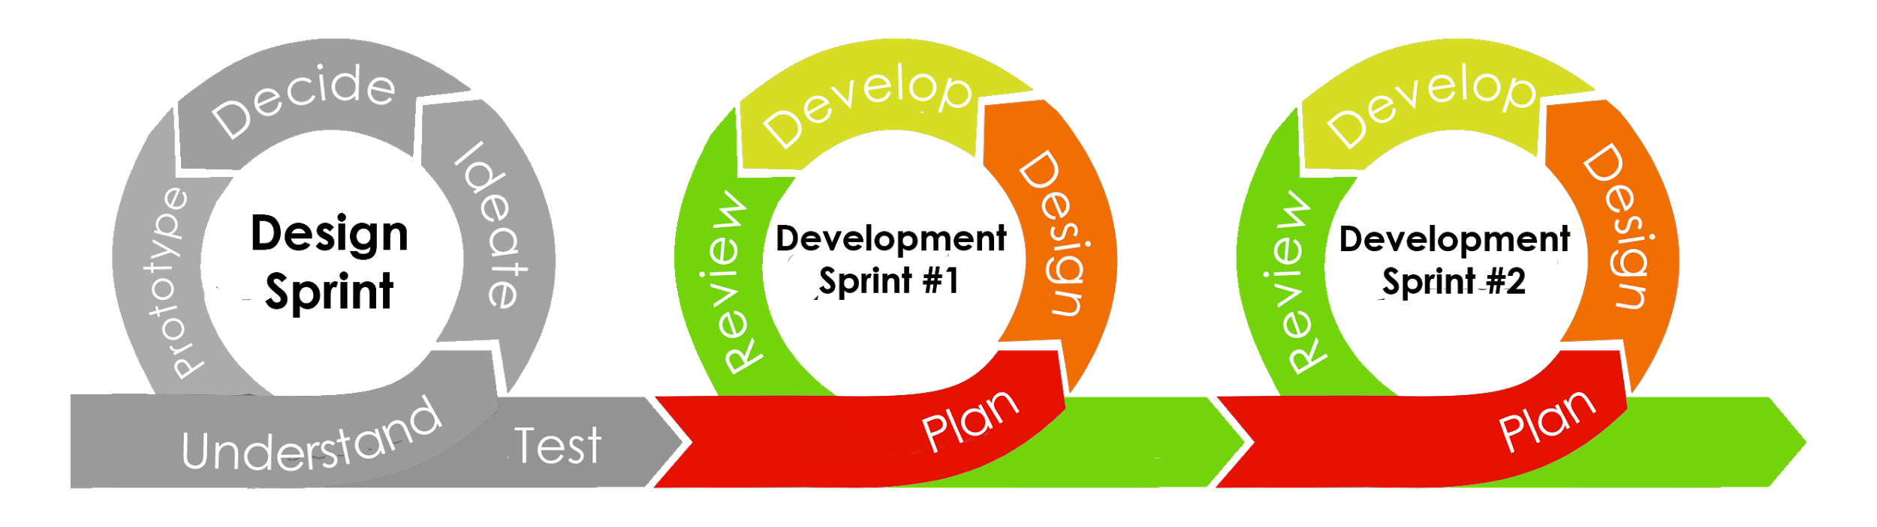

Outline
You have designed your web outcome using a design sprint. You can now develop it.
If you are working in a team you can work together to develop one of the designs from the design sprint - it need not be your own design.
However, this will involve testing and re-designing in iterative cycles.

You must complete all phases of the Development Sprint at least once.
It is recommended that you complete at least THREE development sprints.

Each sprint should take 8-10 hours (typically 2 weeks of class time).
At least half of this time should be spent on the develop phase.

Use Advanced Techniques
At NCEA Level 2 you need to use advanced techniques in your website. These could include:
- Using a library, such as W3.CSS, Bootstrap or jQuery in your website
- Creating or customising javaScript (or other) code to create effects
- Using a combination of steps (in HTML and/or CSS) to make your elements look or function better

Use Efficient Tools and Techniques
To create a high-quality outcome (Excellence) you will need to use efficient tools and techniques.

This could include
- Commenting your HTML and CSS code thoroughly
- Validating your HTML/CSS code at each testing phase
- Using a single external stylesheet for your CSS rather than writing it inside your HTML
- Using semantic tags, class and id in a way that avoids unnecessary coding
- Following file naming and folder conventions
- Clearly labelling and keeping all your versions of your website, images and text

DEVELOPMENT SPRINT

Development Phase 1 - Plan

1  Plan | 2  Design | 3  Develop | 4  Review

Aim
Your aim in the Plan phase is to decide what you need to develop in this sprint.

In this section you should try to show evidence of
- using appropriate tools and techniques for the purpose and end users
- applying relevant conventions to improve the quality of the outcome
- addressing relevant implications

Plan
As a team:
Decide what parts of the outcome can be developed in this sprint and to what extent

Make a note of conventions you will apply. These might include:
- File management and file naming conventions to be used
- HTML and CSS conventions to be followed
- Image types to be used
- Design styles to be followed

Make a note of any efficient tools and techniques you will use. These might include:
- Commenting
- Use of stylesheets and external files
- Validation of HTML and CSS
- Optimisation of images and media
- External libraries to be used (e.g. bootstrap)

Make a note of any relevant implications you are trying to address in this sprint.

Development Phase 2 - Design

1  Plan | 2  Design | 3  Develop | 4  Review

Aim
It is highly likely that in each iteration, elements of the design will need to refined or redesigned in response to changing user requirements or additional information that has become available.

If this is the first Development Sprint, you need only present your final design from the design sprint, but you can make changes here if you wish.

In this phase you need to show evidence of:
- iterative improvement throughout the design, development and testing process to produce a high-quality outcome
- using information from testing procedures to improve the quality of the outcome
- applying relevant conventions to improve the quality of the outcome

Design
In your project log add notes or sketches of new things to be added or how things will be changed.

You might need to trial variations of the design.
E.g. You could pick 3 different fonts and model each one, then decide which to use for your header

Make sure you refer to relevant conventions you are using.
Make sure you refer to the testing procedures that inspired the change.

Development Phase 3 - Develop

1  Plan | 2  Design | 3  Develop | 4  Review
Aim
This phase is the biggest part of your development sprint.
This is the phase where you actually write the code and build your outcome.

You need to show evidence of:
- using appropriate tools and techniques for the purpose and end users
- using relevant conventions for the media type
- applying relevant conventions to improve the quality of the outcome

Develop
Build a new iteration of your outcome.

Make sure that you apply the conventions and use the efficient tools and techniques you identified in the Plan phase.

Make sure that you submit and backup this version of your outcome.
You may need to upload the full website folder.

You will need to carry out basic testing (e.g. viewing the website in the browser) during this stage.

You want to develop each component you are working only to the minimum standard so that it can be tested.

Development Phase 4 - Review

1  Plan | 2  Design | 3  Develop | 4  Review
Aim
You need to test your outcome and get feedback so you can improve it.

You need to show evidence of
- applying appropriate data integrity and testing procedures
- using information from testing procedures to improve the quality of the outcome (merit)
- iterative improvement throughout the design, development and testing process to produce a high-quality outcome (excellence)

Test
In your project log, record screenshots or screen videos of testing and feedback. Testing could include:
- Proofreading / Spellchecking / Grammar checking / Getting feedback
- Validating HTML/CSS
- Viewing in different browsers (e.g. Chrome, Firefox, Edge, Safari)
- Viewing in different screen sizes or on different devices
- Checking links and buttons function correctly
- Usability testing (recording feedback against usability heuristics)
- Visual impairment or colour blindness simulator
- Testing loading times for images or media
- Checking copyright information for media

You could submit
- Screenshots or Screen videos
- Interviews with users
- User feedback comments
- Quick notes on what was done

When testing is complete, return to the start of the Development Cycle and Plan the changes you will make.

In the final review at the end of the last iteration, you should record an interview with your assessor or another student. You should answer the questions:
- Can you explain the most relevant implications of your web outcome?
- How did you address these implications?
- How did you apply conventions to improve the quality of the outcome?
- What efficient tools and techniques did you use in your development process?

